**12 ATAR Physics**

**Electromagnetism Investigation**

**Part 1 - Research**

**Name:**

**The Betatron**

The betatron is a device for accelerating electrons (also known as beta particles) to high speeds using induced electric fields produced by changing magnetic fields. Such high-energy electrons can be used for basic research in physics as well as for producing *x*-rays for applied research in industry and for medical purposes such as cancer therapy.

The betatron provides an excellent illustration of the ‘reality’ of induced electric fields. Typically, betatrons can produce energies of 100 MeV (mega Electron Volts), in which case the electrons travel at speeds close to the speed of light (*v* = 0.999987*c* where *c* is the speed of light). Betatrons can produce enormous currents, in the range of 103 and

105 A.

Fig. 1 below shows a cross-section through the inner structure of a betatron. It consists of a large electromagnet **M**, the field of which (indicated by the field lines) can be varied by changing the current in coils **C.** This is done by applying alternating current to the coils.

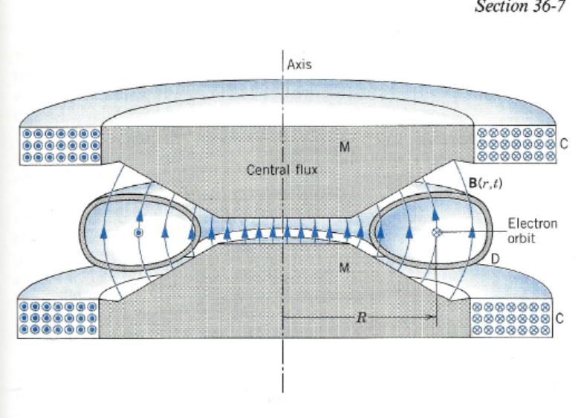

*Fig. 1 A cross section of a betatron, showing the orbit of the accelerating electrons and a ‘snapshot’ of the time-varying magnetic field at a certain moment during the cycle. The magnetic field is produced by the coils* ***C*** *and is shaped by the pole pieces* ***M****.*

Fig. 2 shows a top view of the betatron. The electrons are injected in a direction perpendicular to the external magnetic field so that electrons can follow a circular path.

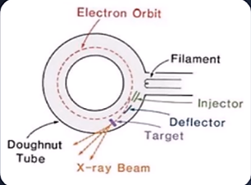

*Fig. 2 Top view of a betatron*

In Fig. 1, the electrons circulate in the evacuated ceramic doughnut-shaped tube marked **D**. Their orbit is at right angles to the plane of the figure, emerging from the left and entering at the right.

Due to the change in magnetic field, an emf is induced in the chamber. The induced emf accelerates the electrons.

The changing field must have positive slope ( so that if the electrons are to be accelerated (rather than decelerated) during the cycle.

Only the first quarter-cycle of Fig. 3 below is useful for the operation of the betatron; the electrons are injected at and extracted at . For the remaining three-quarters of a cycle, the device produces no beam.

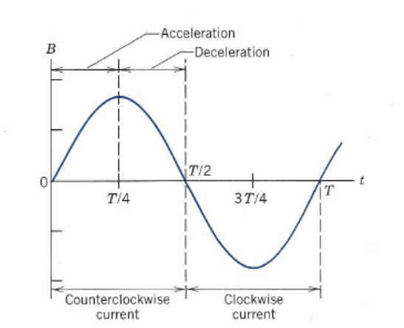

*The variation with time of the betatron magnetic field B during one cycle*

The electrons are made to strike the target (see Fig. 2) just at the end of the first cycle, when their velocity is the highest. This leads to the production of x-rays, gamma radiation etc.

***Task***

Research the betatron and study how it makes use of both the Lorentz force and electromagnetic induction.

You can refer to the following websites as a starting point.

During your validation, you may bring this article and your research along.

***Possible references***

1. What is an electron volt

<https://www.britannica.com/science/electron-volt>

2. <https://www.britannica.com/technology/particle-accelerator/Constant-voltage-accelerators#ref60511>

3. <https://physics.tutorvista.com/modern-physics/betatron.html>

4. <https://sites.google.com/site/puenggphysics/home/unit-iii/betatron>

5. Youtube betatron NJPhysics

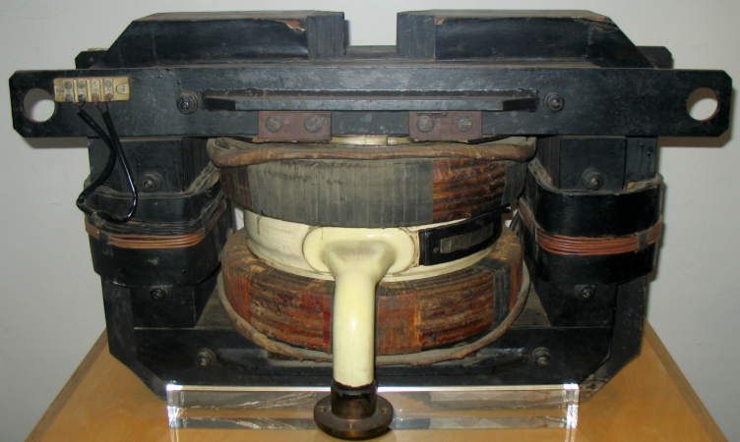

*Fig. 4 A German 6 MeV betatron*